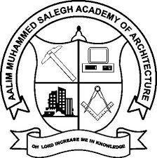

AMSSAC ADVISOR - Ar. Abdu Rahman Meera S
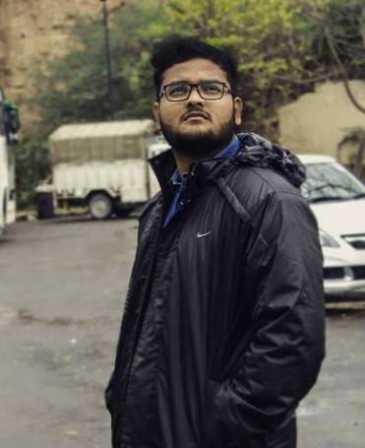

AMSSAC STUDENT'S ADVISOR - Mohammed Irshad Khan.F
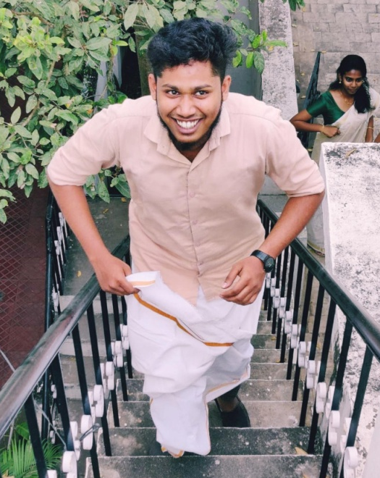

PRESIDENT - Kavitha.S
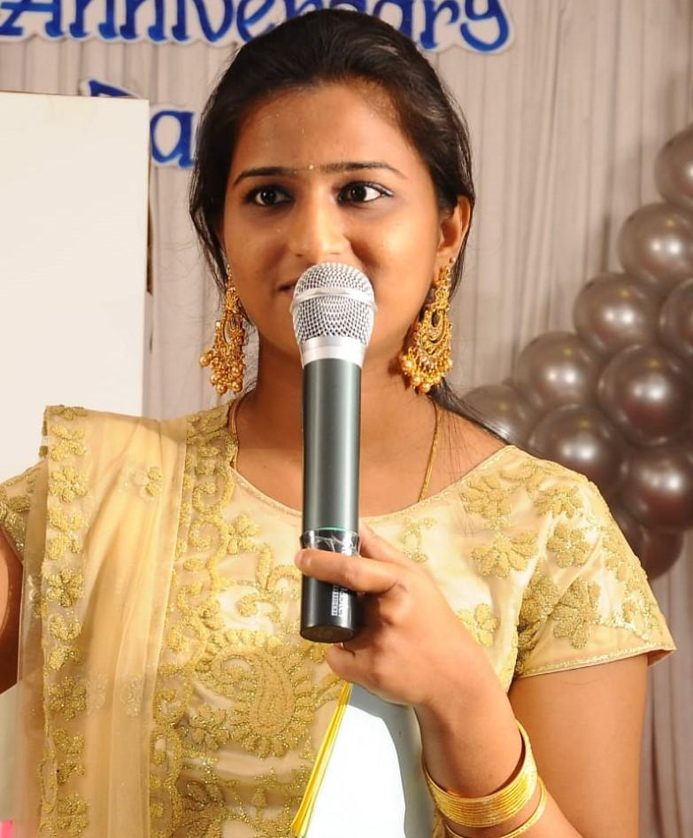

VICE PRESIDENT & ADMISSION - Mohamed Ali.S
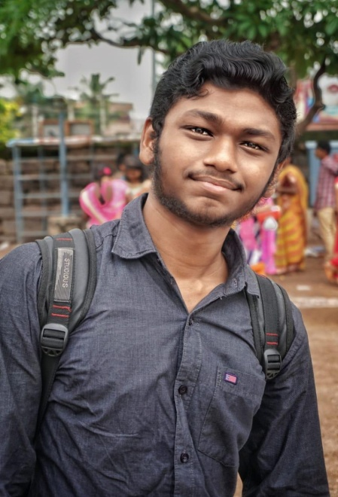

TREASURER - Vasuki.S

DEPARTMENT HEADS
1) ALUMNI & PLACEMENT - Mohammed Aashiq.A
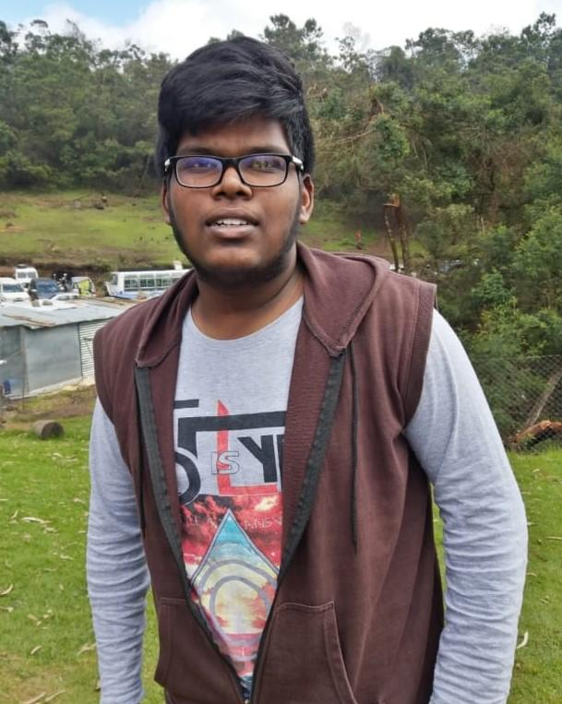
2) SKILL DEVELOPMENT & COMPUTER LABS - Rabiudeen.S
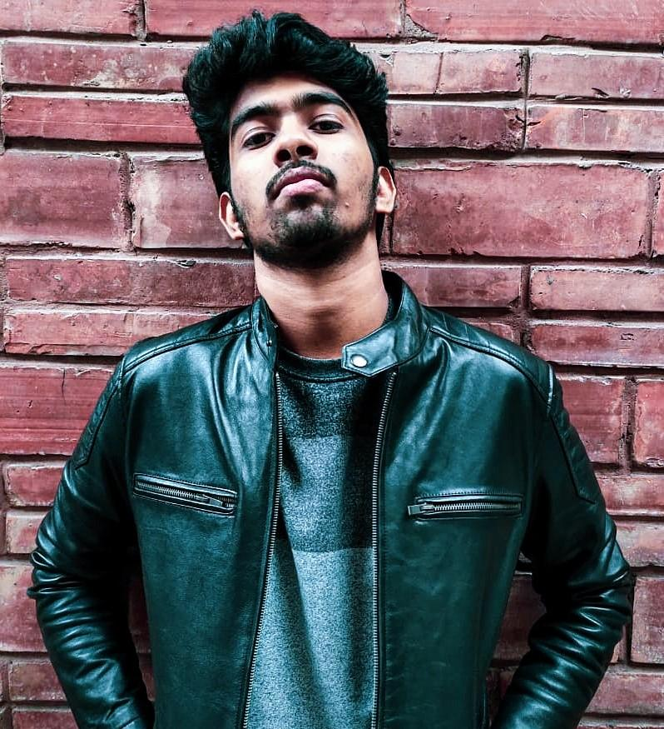
3) ACADEMICS - Ashok.A
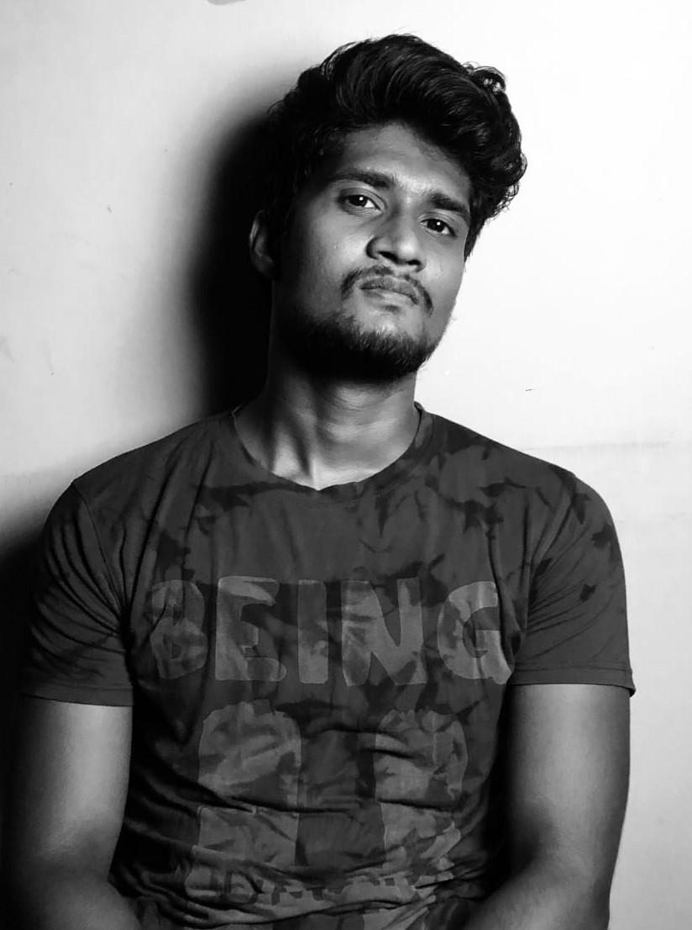

4) RESEARCH & CONSULTANCY - Hari krishnan.R
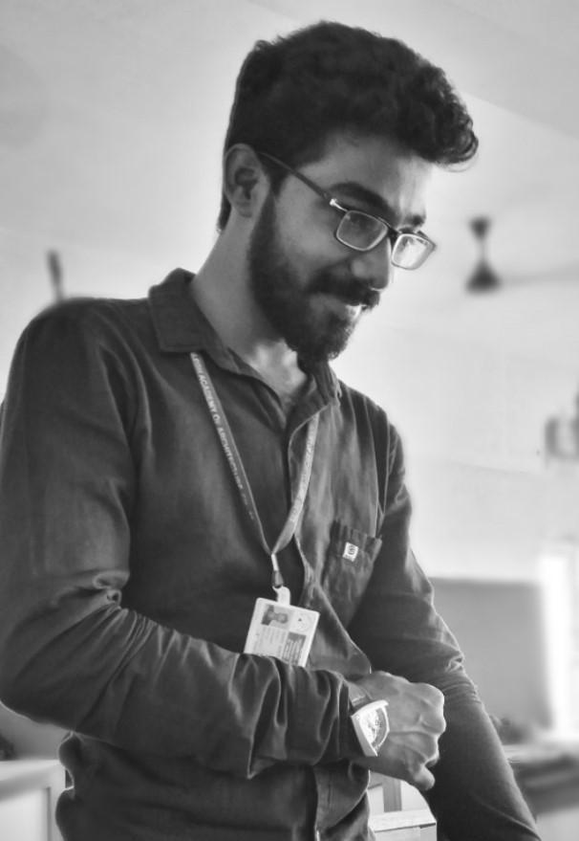

5) STUDENT WELFARE [BOYS] - Nishaal Frazer Shivaji
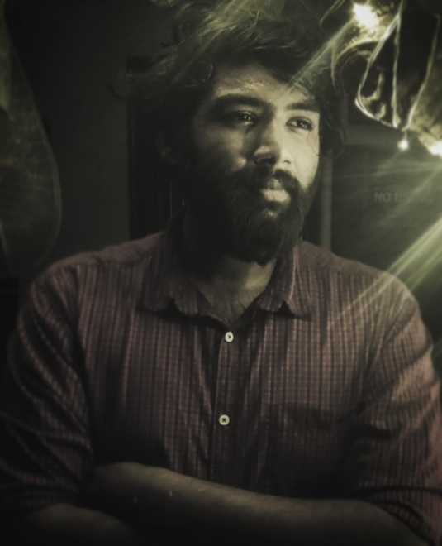
6) STUDENT WELFARE [GIRLS] - Shanu Firmina.J
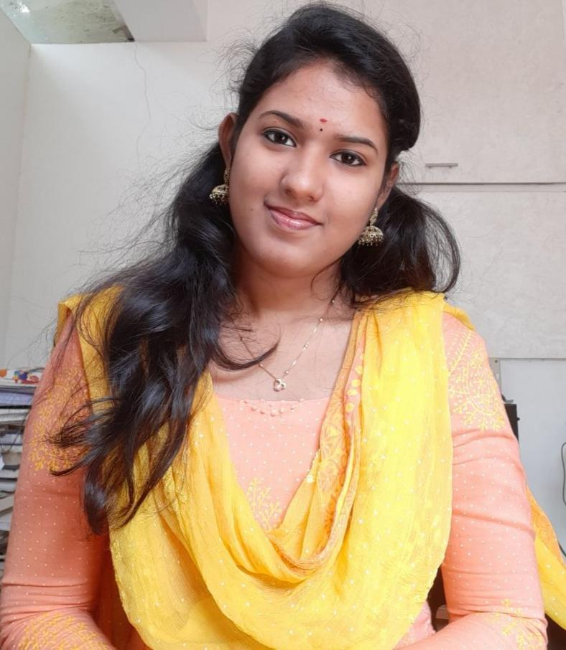

7) CULTURALS - Ameer Salih.H
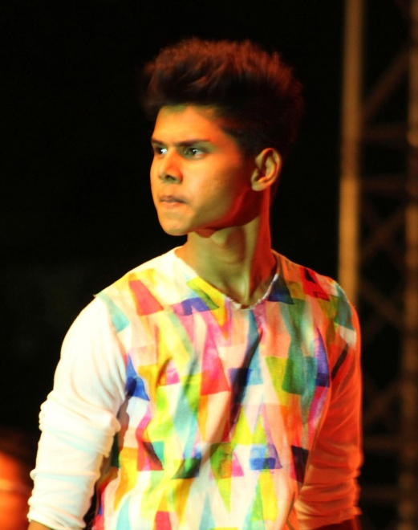

8) COMPETITIONS - Rohith Lakshman.L.M
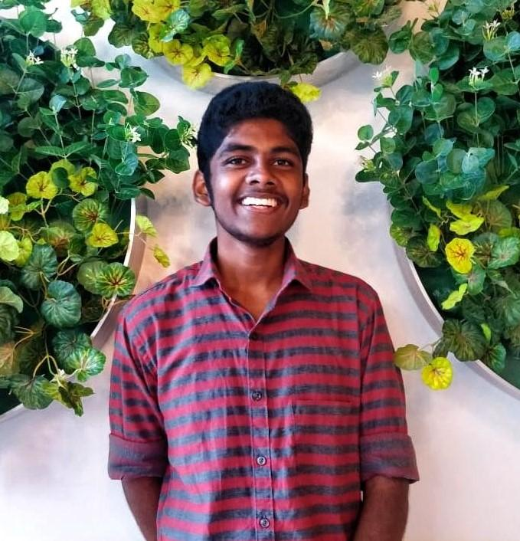

9) LIBRARY & PUBLICATIONS - Jazeel Ahamed.H
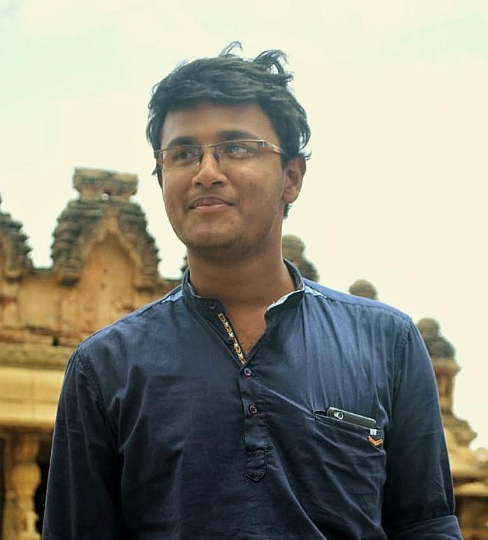

10) FACILITIES AND PROJECT MANAGEMENT - Abrar Ul Haque
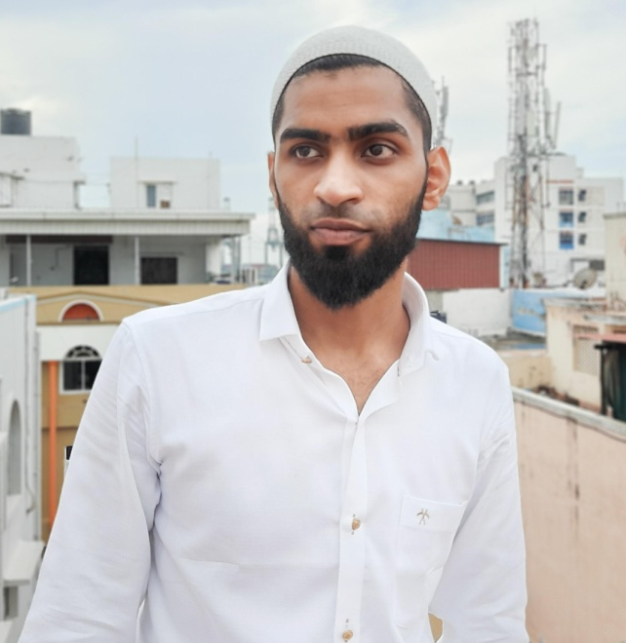

11) NASA - Ranjith Krishnan.T.U
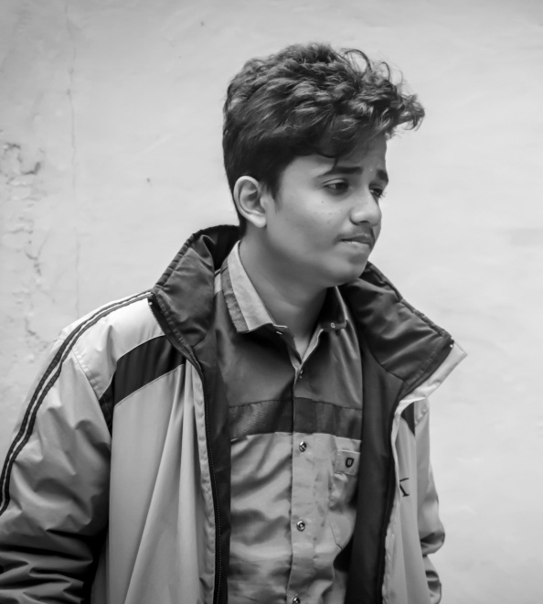

12) SPORTS [BOYS] - Thirukumaran.N.P
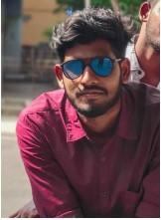

13) SPORTS [GIRLS] – Keerthika.A 